Bug Report – Swag Labs (Shopping Cart Module)

ID: 🐞BUG-CART-01
Title: Verify Cart Item Quantity Can Be Updated
Module: Shopping Cart
Environment:
- Website: https://www.saucedemo.com/
- Browser: Google Chrome
- OS: Windows 11
Prerequisites:
- User is logged in (standard_user / secret_sauce).
- At least one item is in the cart.
Steps to Reproduce:
1. Navigate to https://www.saucedemo.com/
2. Enter username 'standard_user'
3. Enter password "secret_sauce"
4. Click on "Login" button
5. On the Products page, add an item to the cart (e.g., "Sauce Labs Backpack").
6. Navigate to the Cart page by clicking the cart icon in the header.
7. Locate the item in the cart and find the Quantity field (expected behavior: an editable input or +/- buttons should exist).
8. Update the item quantity from 1 to 2.
9. Check if the cart auto-updates.
10. Observe the item subtotal and overall cart total.
11. Try reducing the quantity back to 1.
12. Attempt to input invalid values (e.g., 0, -1, or non-numeric characters).
Expected Result:
- Updating item quantity is not supported; the value remains constant
Actual Result: The application provides no option to update item quantity in the cart.
Attachments:
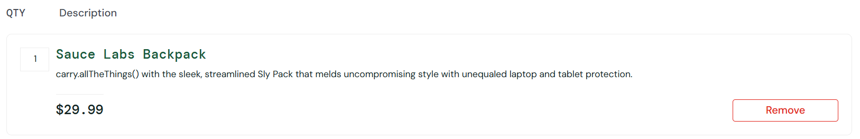

Severity: High.
Priority: High.

ID: 🐞BUG-CART-02
Title: Wrong product details displayed when clicking on Backpack item
Module: Shopping Cart
Environment:
- Website: https://www.saucedemo.com/
- Browser: Google Chrome
- OS: Windows 11
Prerequisites:
- User is logged in (problem_user / secret_sauce).
- At least one item is in the cart.
Steps to Reproduce:
1. Navigate to https://www.saucedemo.com/
2. Enter username ‘problem_user’
3. Enter password "secret_sauce"
4. Click on "Login" button
5. On the Products page, add an item to the cart (e.g., "Sauce Labs Backpack").
6. Navigate to the Cart page by clicking the cart icon in the header.

Attachments:
- Screenshot 1: Product listing page showing Backpack.
- Screenshot 2: Wrong product page displayed (Fleece Jacket).
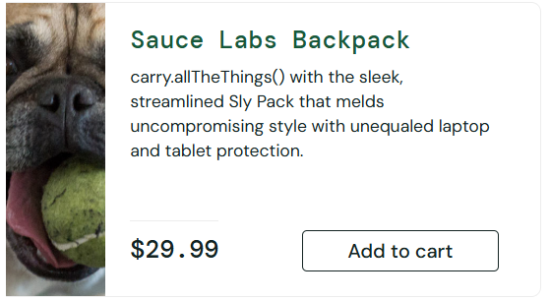

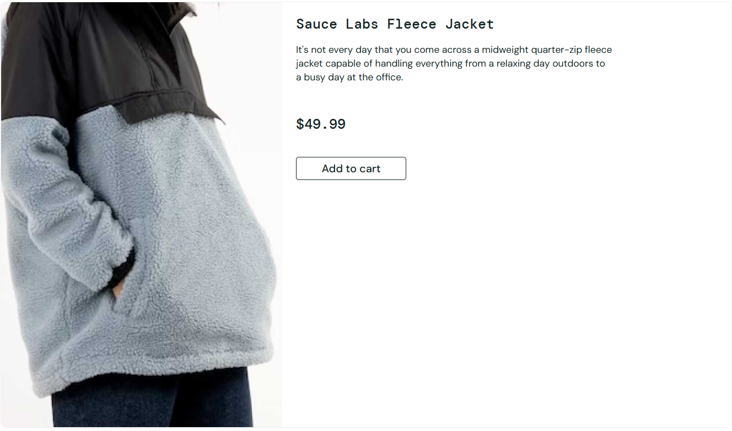
Expected Result:
- The product details page for Sauce Labs Backpack should be displayed, showing the backpack image, description, and price $29.99.
Actual Result: The product details page for a different item (Sauce Labs Fleece Jacket, $49.99) is displayed instead of the backpack.
Severity: High.
Priority: High.

ID: 🐞BUG-CART-03
Title: User is able to proceed to checkout with an empty cart
Module: Shopping Cart
Environment:
- Application: Swag Labs (Web)
- URL: https://www.saucedemo.com/cart.html
- Browser: Chrome 140.0.0.0
- OS: Windows 10 (64-bit)
Preconditions:
- User is logged into the application.
- User has not added any items to the cart.
Steps to Reproduce:
- Log in to Swag Labs.
- Navigate to the Cart Page without adding any products.
- Observe that the cart is empty (no items listed under QTY/Description).
- Click on the Checkout button.
Actual Result:
- The system allows the user to proceed to the Checkout Information Page even though the cart is empty.
Expected Result:
- The system should not allow checkout with an empty cart.
- A clear validation message should be displayed to inform the user that checkout is not allowed when the cart is empty.
Actual Result:
- The system allows the user to proceed to the Checkout Information Page even though the cart is empty.
Attachments:
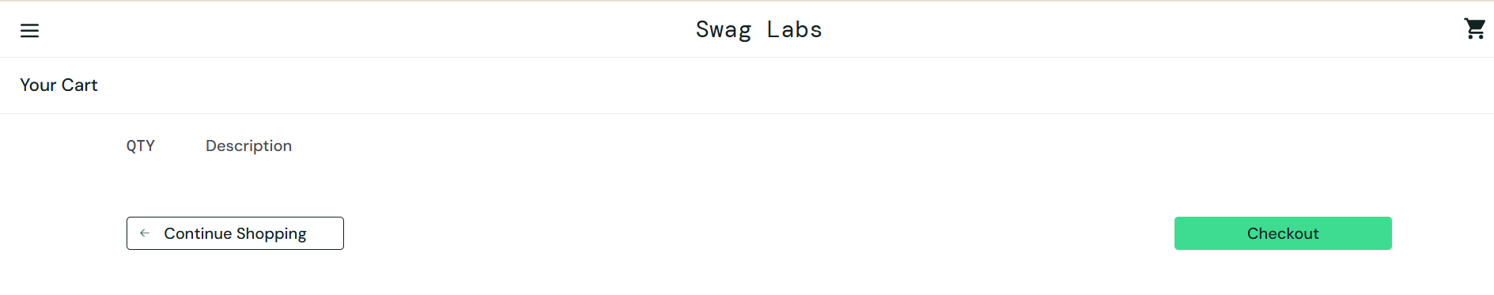
Impact:
- Users can bypass the cart validation and proceed to checkout with no items, leading to invalid orders and broken purchase flow.
Severity: High
Priority: Medium

